Employee Performance & Recognition Portal

Abstract:

Employee Performance and Recognition Portal is online Performance Appraisal and Recognition system used by all the employees in different sections of the company. Salary hike and promotion depends upon the employee performance. This portal is a one stop shop for all the employees to provide details like tasks performed and performance measures improved etc to their superiors. It allows superiors to evaluate and analyze the employee’s performance and work done by him and target achieved in a given period of time and to rate him. It provides a very good interface between superiors and subordinates. Based on these ratings and overall performance shown by employees ranks will be allotted to them among the group of employees with same designation. This rank is called consolidated rank. This is the basic criteria for recognizing employee’s performance and to provide salary hike/promotion to any employee.

This application maintains the entire data in a centralized and secured database server to maintain consistency in report generation and allows users to access from any location. This is an online application that allows multi user access of system and to track or manage the data simultaneously. Various roles and authentications have been provided and access to various areas in the tool is restricted according to the role given to users.

The aim of this application is to reduce the manual effort needed to manage the details of tasks and performance measures of each and every employee which is very tedious. And maintaining historical data used by HR team in generating consolidated data is not possible. This portal helps them in generating consolidated rank or required reports with a single click. Also this application provides an interface to management and other users to manage the details of and to generate required reports. This helps to prevent unnecessary delays and human errors. This system helps in generating foolproof reports with in not time by users which is very difficult in current system (manual system).

This system design is modularized into various categories. This system has enriched UI so that a novice user did not feel any operational difficulties. This system mainly concentrated in designing various reports requested by the users as well as higher with export to excel options.

Features
- 24 X 7 availability
- Better component design to get better performance at peak time
- Flexible service based architecture will be highly desirable for future extension
- Professional look and feel
- Browser testing and support for IE
- Website is highly customizable and flexible enough to easily deploy without much effort
- Secured data driven role based access

Project Scope: This intranet application has been developed to be implemented in place of existing manual system. This application provides effective appraisal system for the employees by evaluating their performances and retains the present functionality available in the current system. The specific purpose of this system is to store and process information about different tasks, weightage, self ratings and final rating at different stages and generates the reports as and when required. The administrator is responsible for maintenance of this system. Based on the Type of user category of the user i.e. administrator, appraisee, appraiser, reviewer the various parts of the system are made available.

Problem Statement

Problem statement is one of the basic and important phases of project development. When the basic problem is determined, it is documented and the symptomatic problem is analyzed, then the current list of basic problem is completed. A system is simply a set of components that interact to accomplish some purpose.
In “DCKMS” maintaining the details of different types of tasks, their status, details of tasks, their self rating, login details of the different types of users (Appraisee, Appraiser, Reviewer, and Admin), personal details of the employees. Final evaluation details, employee average rating and consolidated rank details are to be kept in a database and also can be retrieved easily when the authorized user wants to get or update the data.
Actually the process going on here is when the user (employee) submits his task details then he needs to store inside an excel sheet and send it to his appraiser manually and if appraiser wants to send evaluated rating details to the employee then he needs do the same thing. Evaluating each and employee task details, calculating average rating of all the employees yearly for two times and finally generating consolidated tanks based on some criteria at different levels leads to human errors in the current system.
System Analysis:

System Analysis is first stage according to System Development Life Cycle model. This System Analysis is a process that starts with the analyst.
Analysis is a detailed study of the various operations performed by a system and their relationships within and outside of the system. One aspect of analysis is defining the boundaries of the system and determining whether or not a candidate system should consider other related systems. During analysis, data are collected on the available files, decision points, and transactions handled by the present system.
Logical system models and tools that are used in analysis. Training, experience, and common sense are required for collection of the information needed to do the analysis.

Existing System:
Here the existing system is nothing but a manual system in which the employees has to fill their rating details in an excel sheet and send it to their supervisor then the supervisor has to merge all the employee rating details and arrange them in to a single sheet. Calculating the average rating of the employees by considering the no of tasks they have done and their weightage into consideration and finally generating a rank is a tedious process in this system.
Drawbacks:
- Difficulty in maintaining employee individual rating information in an excel sheet.
- More manual hours need to calculate average based on different constraints and generating
- Difficulty in maintaining role based security.
- Difficulty in co-relating different ratings.
- Doesn’t provide effective communication between different levels of employees.
- Doesn’t provide security.
- Difficulty in generating the reports
- Difficulty in generating different reports

One way to overcome all these difficulties is so store all the information in the computer. The computerization helps the users a lot.

Proposed System: The Employee Performance and Recognition Portal is to replace the existing manual system with a software solution. It allows all the employees in different sections of the company to post rating details individually which will be forwarded to their appraiser. It allows the appraiser to re-rate the employee individual task ratings which takes into consideration and calculates average rating of the all employees based on no of tasks they have done, their ratings and weightage. Based on these average ratings this system will generate consolidated ranks for the employee automatically with any errors.

- Faster processing when compared to existing one
- Centralized database helps in avoiding conflicts
- Easy to use GUI that does not requires specific training
- Provides facility for the employees (appraise) to post their rating details which will be forwarded to their appraiser effectively
- Allows the appraiser to re-rate the employee ratings
- It helps in calculating the average rating of the employees and generates consolidated ranks.
- Helps in generating different reports within no time.

Requirements Analysis

The requirement phase basically consists of three activities:
- Requirement Analysis
- Requirement Specification
- Requirement Validation

Requirement Analysis:

Requirement Analysis is a software engineering task that bridges the gap between system level software allocation and software design. It provides the system engineer to specify software function and performance indicate software’s interface with the other system elements and establish constraints that software must meet.
The basic aim of this stage is to obtain a clear picture of the needs and requirements of the end-user and also the organization. Analysis involves interaction between the clients and the analysis. Usually analysts research a problem by asking questions and reading existing documents. The analysts have to uncover the real needs of the user even if they don’t know them clearly. During analysis it is essential that a complete and consistent set of specifications emerge for the system. Here it is essential to resolve the contradictions that could emerge from information got from various parties. This is essential to ensure that the final specifications are consistent.
It may be divided into 5 areas of effort.

- Problem recognition
- Evaluation and synthesis
- Modeling
- Specification
- Review
Each Requirement analysis method has a unique point of view. However all analysis methods are related by a set of operational principles. They are

- The information domain of the problem must be represented and understood.

- The functions that the software is to perform must be defined.

- The behavior of the software as a consequence of external events must be defined.

- The models that depict information function and behavior must be partitioned in a hierarchical or layered fashion.

- The analysis process must move from essential information to implementation detail.

Requirement Analysis in this Project

The main aim in this stage is to assess what kind of a system would be suitable for a problem and how to build it. The requirements of this system can be defined by going through the existing system and its problems. They discussing (speak) about the new system to be built and their expectations from it. The steps involved would be

Problem Recognition:
The main problem here is the more time is taken to manage the different task of all the employee and forwarding them appropriate appraisers and finally evaluate them manually. This has to be eliminated. A comprehensive solution has to be developed which will facilitate to fulfill the requirements faster and more efficient way.

Evaluation and Synthesis:
The system has to be designed only after complete evaluation of the existing one, upon which we can see that a lot depends on the medium of communication. The proposed system is used to maintain all the employee task details in the database appraiser wise, to avail them to all the appraisers. So this has to be used such that there is no waste of time.

Specification:
The specifications from the user, here maintaining all documents of the employees manually lead to unnecessary submissions. The appearance of forms, and their field names, the different screens he desired, the stages of this database etc., were all given. The system has been built following all the specifications.

Requirements Specification

Introduction

According to Roger Pressman in Software Engineering: A Practitioner's Approach (McGraw-Hill Publications) [SEPA–1997], the requirement specification document is produced at the end of Analysis of the system. This document is a very comprehensive document & contains all the User requirements & Analysis diagrams. The Requirements are broadly divided into two groups:
1. Functional requirements
2. Non-functional requirements

Functional Requirements Specification

Hierarchy of Users
The hierarchy of the system is maintained by the privileges to access the system. There are three types of users.

Appraise: Every employee is an appraisee and submits his appraisal to his manager with task details for evaluation. He can view his/her profile. Employee can check for task details, view appraisal. He can check the status of his appraisal application.

Appraiser: Appraiser is appraisee’s reporting manager. Main function is to evaluate appraisal request being sent by appraisee to his appraiser. He can verify the appraisee’s appraisal request.

Admin: Admin can add the employees by creating logins with roles. He can view the list of currently available employees.
He can checks for appraisal requests, add project, allocate projects to employees and also see the appraisal report.

Product Scope and Functional Specifications

Scope:
The functional scope of Employee Performance & Recognition Portal is to provide a user-friendly management system for resources as well as to give a tracking of employee appraisals, which tracks the employees performance and appraisals. .

The following functional activities are considered for executing the project.

- Every employee (appraisee) can submit their appraisal to his manager (appraiser).
- Every appraisee can prove their performance based on the tasks those they are completed successfully.
- Appraiser’s work is to evaluate appraisals and send it to the admin.
- Admin can view the appraisee request and approve them accordingly.

Reports should be generated on the current status and every report will be accountable by the employees of the company.

      - No of Employee – This report can show the total employees of the company.
      - Appraisal calculation – This report can show all the employees appraisal calculations.

Database: The Employee Performance & Recognition Portal application has the JDBC- connectivity, which is provided to interface with Oracle 10G database. The Oracle 10G is chosen for this project because of higher security level and web compatibility features offered by it and it is open source.

Non-Functional Requirements:

1) Documentation:
User is provided a manual in the system. This will guide user or the operator in driving the system in a perfect manner. There is no need to specify the technical documentation for the user.
2) Hardware Considerations:
If the software is to be executed on existing hardware or on predetermined software, all the characteristics of the hardware, including memory restrictions should be specified. In addition, the current use and load the characteristics of the hardware should be given:

Configuration Required Recommended
Main Memory 256 MB 512 MB
Microprocessor PentiumIV PentiumIV
Hard disk Drive 40 GB 80 GB
Printer Any Printer Any Printer
The system should be consisted with the hardware such that any up gradations made to the current system should support.

3) User Interface and Human Factors:
The user interface used is a graphical user interface (GUI). When the user clicks buttons, select the checkbox item, uses the mouse or perform any relate action, an interface event occurs.
A little training for the user to the system is needed. A preliminary user manual with all user commands, screen formats. An explanation is giving how to feedback and error messages.
4) Modifiability:
The system is consisting with future modifications. In future, if
any changes to the system are required they can be done easily without changing the overall.
5) Security Issues:
The system should be protected against security threats. The
Organization has the responsibility to restrict the threats such as external instructions, malicious users. The company should deploy instruction detection technique. Security to the system is provided with login and password.
6) Resource Issues:
Developers should be take concern about resource utilization issues the resources must be used in reasonable and efficient manner. Insufficient use of the resources request in the increase of cost of automation of project over manual system.

Software and hardware requirements

Development Environment

- Operating System: Windows 2007/XP
The system will be built on windows compatible environment. The application will be web based using Java technology
- Web Server:
Apache Tomcat Web Server to serve as Servlet\JSP engine. The system requires Apache Tomcat Web Server
- Server side Application Software: Java Server Pages (JSP)
- Client Side Application Software: Java Script, HTML,CSS
- Data Base: Oracle 10G
The system requires Oracle as a database, however the system will be JDBC complaint to work on any standard database.
- Client Browsers: Google chrome or Opera
- Java Software : Jdk1.7.0
- Hardware: Pentium PCs with 256 MB RAM/ 80 GB HDD.

Feasibility Study

All projects are feasible given unlimited resources and infinite time. But the development of software is plagued by the scarcity of resources and difficult delivery rates. It is both necessary and prudent to evaluate the feasibility of a project at the earliest possible time.

Three key considerations are involved in the feasibility analysis.

Economic Feasibility:

This procedure is to determine the benefits and savings that are expected from a candidate system and compare them with costs. If benefits outweigh costs, then the decision is made to design and implement the system. Otherwise, further justification or alterations in proposed system will have to be made if it is to have a chance of being approved. This is an ongoing effort that improves in accuracy at each phase of the system life cycle.

Technical Feasibility:

Technical feasibility centers on the existing computer system (hardware, software, etc.,) and to what extent it can support the proposed addition. If the budget is a serious constraint, then the project is judged not feasible.

Operational Feasibility:

People are inherently resistant to change, and computers have been known to facilitate change. It is understandable that the introduction of a candidate system requires special effort to educate, sell, and train the staff on new ways of conducting business.

Feasibility Study in This Project

Technical Feasibility
This project, Employee Performance and Recognition Portal needs the support to average technology already being implemented for other useful systems in a company. It requires PC’s and a modem with normal configuration for Internet access. Almost all administrators have their own PC on their desk. Thus it is technically feasible to implement the new system here.

Economic Feasibility
“Employee Performance and Recognition Portal” is a mid-scale project. It is very much useful to employees as well as admin people in reducing manual work which increases the productivity of the company. The infrastructure for the development of their new system is available in the company. The system is developed at no additional cost. Hence it is economically feasible for the new system to be implemented.
Operational Feasibility
This system is being automated on the request of the employees of a company and the management people. This new system meets their requirement and covers all aspects required much better than the old manual system. Most of the people involved in this company are computer literates and do not need much training if this system is implemented. Hence it is operationally feasible.

System Design

The most creative and challenging phase of the life cycle is system design. The term design describes a final system and the process by which it is developed. It refers to the technical specifications that will be applied in implementations the candidate system. The design may be defined as “the process of applying various techniques and principles for the purpose of defining a device, a process or a system in sufficient details to permit its physical realization”.

The designer’s goal is how the output is to be produced and in what format samples of the output and input are also presented. Second input data and database files have to be designed to meet the requirements of the proposed output. The processing phases are handled through the program Construction and Testing. Finally, details related to justification of the system and an estimate of the impact of the candidate system on the user and the organization are documented and evaluated by management as a step toward implementation.
The importance of software design can be stated in a single word “Quality”. Design provides us with representations of software that can be assessed for quality. Design is the only way that we can accurately translate a customer’s requirements into a finished software product or system without design we risk building an unstable system, that might fail it small changes are made or may be difficult to test, or one who’s quality can’t be tested. So it is an essential phase in the development of a software product.

SYSTEM DESIGN phase follows system analysis phase. Design is maintaining record proof design divisions and providing a blueprint for the implementation phase. Design is the bridge between system analysis and system implementation.

System design is transition from a user oriented, document oriented to programmers or database personnel. The design is a solution, a “how to” approach to the creation a new system. This is composed of several steps. It provides the understanding and procedural details necessary for implementing the system recommended in the feasibility study. Design goes through logical and physical stages of development, logical design reviews the present physical system, prepare input and output specifications, detail the implementation plan, and prepare a logical design walkthrough.

The database tables are designed by analyzing various functions involved in the system and the format of the fields is also designed. The fields in the database table should define their role in the system. The unnecessary fields should be avoided because it affects the storage areas of the system. Care is to be taken to encode the lengthy names. Then in the input and the output screen design, the design should be made user friendly. The menu should be precise and compact.

Objectives of Design
System design is like a blue print for a building, it specifies all the features that are to be in the finished product. Design states how to accomplish objectives determined in the analysis phase.
Logical Design:

The design of an information system produces the details that state how a system will meet the requirements identified during systems analysis. This stage is login design.

(a) Module Description:

We have identified the following modules:
Admin Module: This module provides interface to administrator to manage (add /delete / edit) the employees and view the list of currently available employees. It allows admin to create logins for different employees and assign different roles while creation. It allows the administrator to create, delete and view the projects. It provides a facility to store report. It allows the administrator to change his for enhanced security in future.
Appraisee: This module treats every employee as an appraisee and allows them to submits appraisals to his manager which contains task details like Task ID, Task Desc, Task Status, Weightage of the task for the all the task he has done with in this half-yearly period. He can view the appraisals what he has submitted. If he is not satisfied then he can send a request to the appraiser to review his appraisal again.

Appraiser: Appraiser is nothing but Appraisee’s reporting manager. Main function is to evaluate appraisal. After that, he can submit it to the admin. He can view the appraisee requests forwarded from employee.

UML Diagrams:
Use Case Diagram for Admin:

Admin code

Project Management

User Management


Employee Management

View Appraisal Report
Admin

Use Case Diagram for the following Users:

Request for Appraisal
Tasks
Settings

View Profile


Appraisee

View Appraisals

Evaluate Appraisals


Rejected Appraisals
Appraiser

DFD’s:

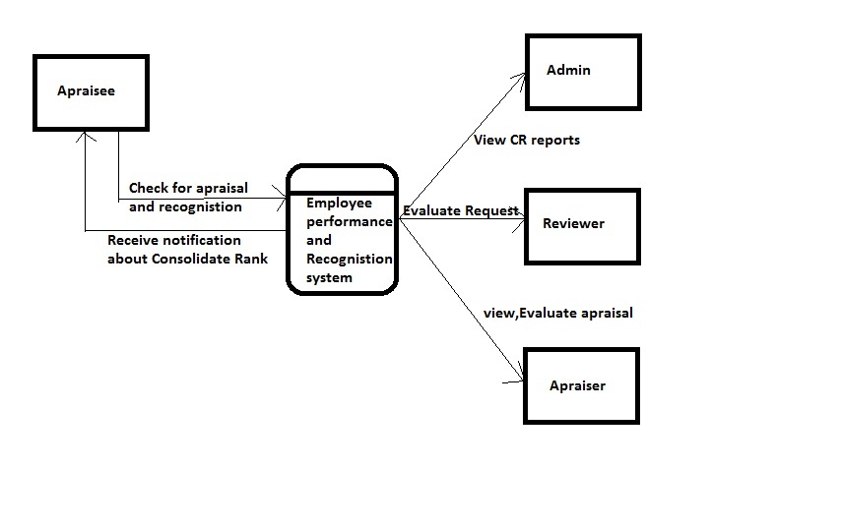
DFD: 0 Level DFD

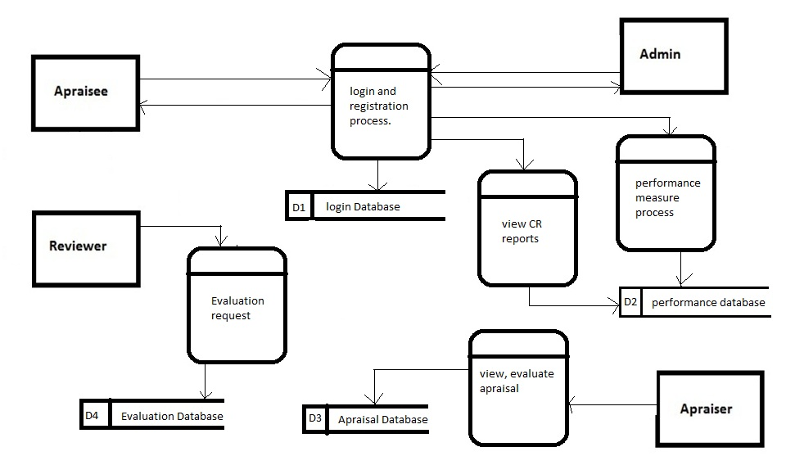
1 LEVEL DFD

Snapshots:

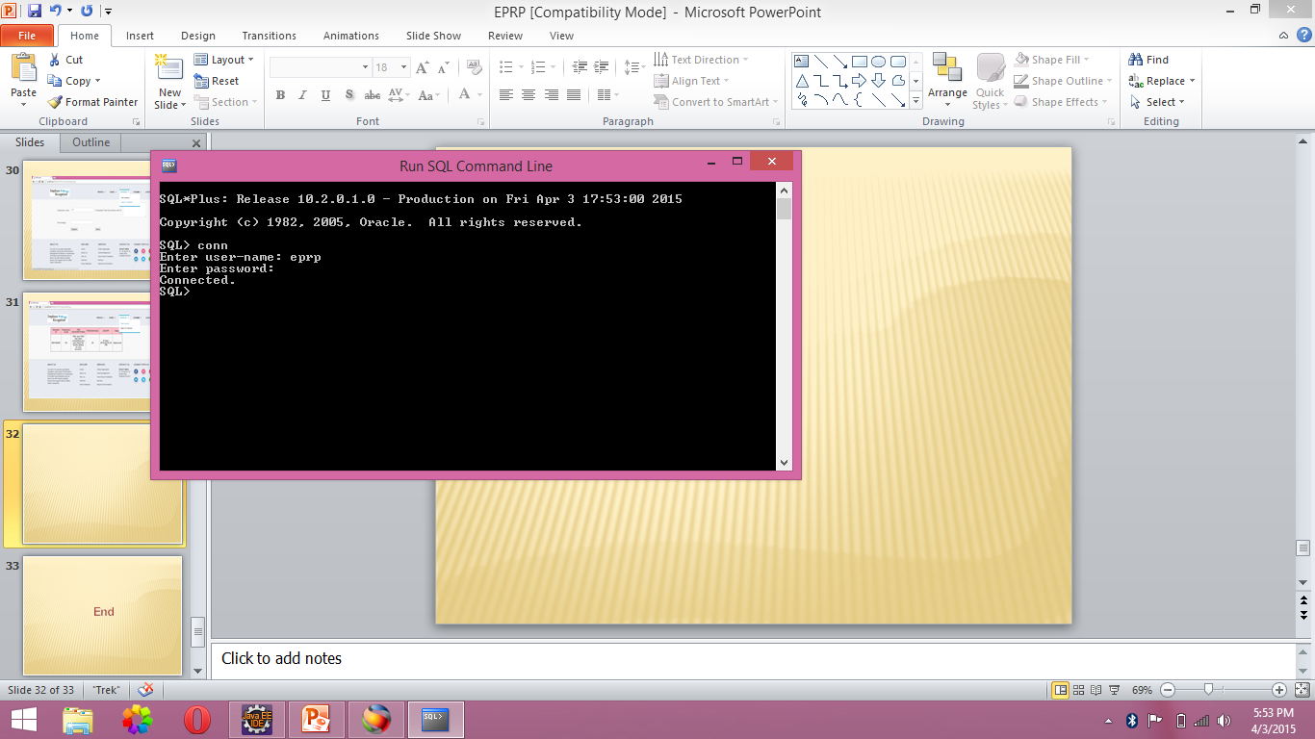

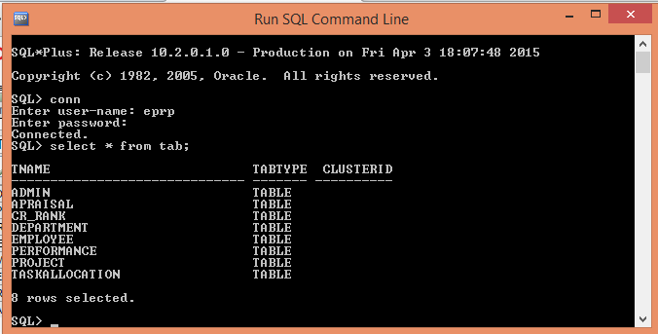

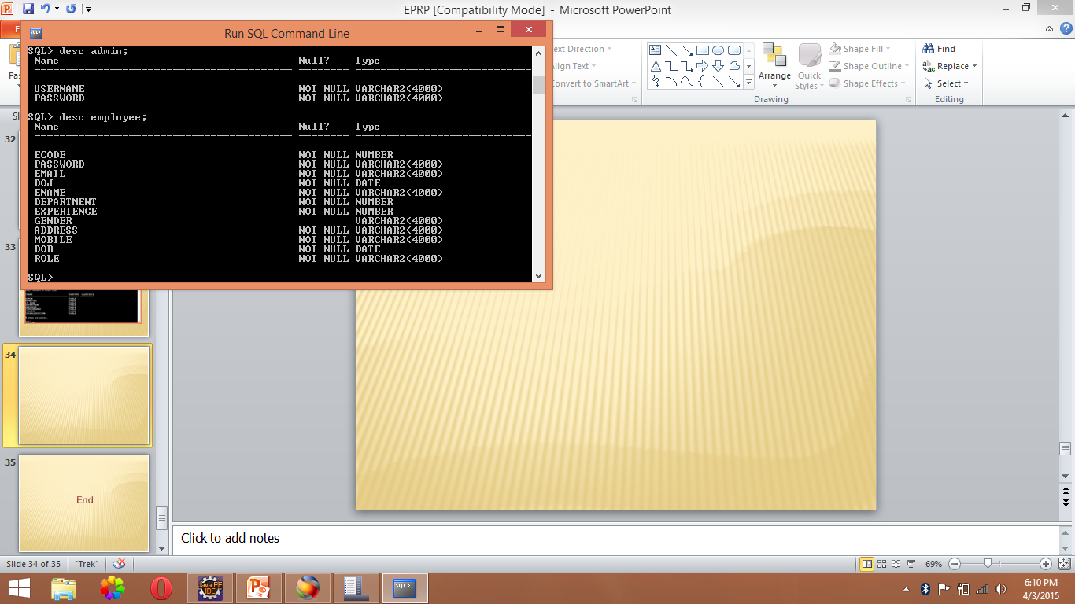

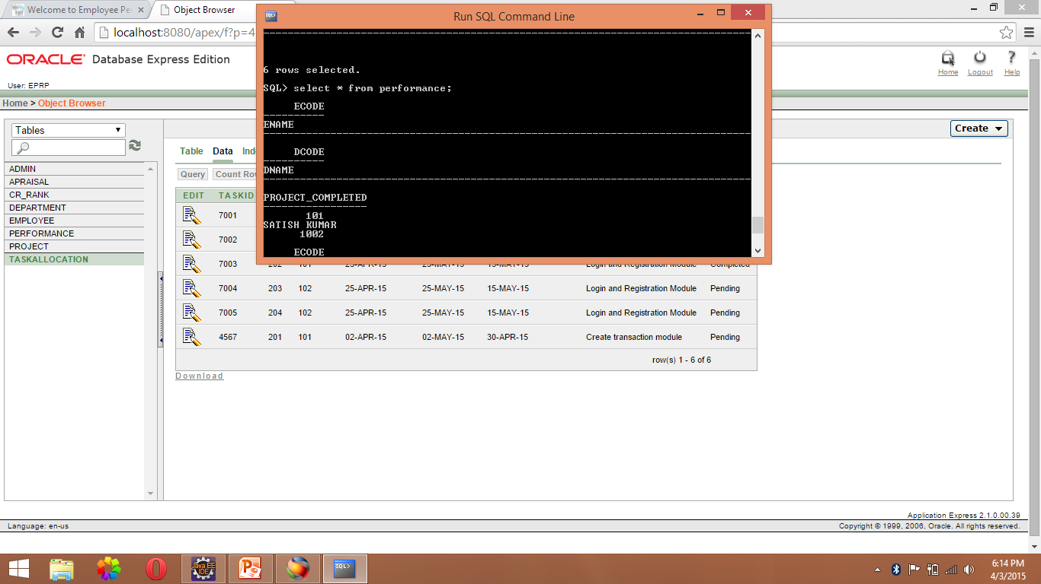

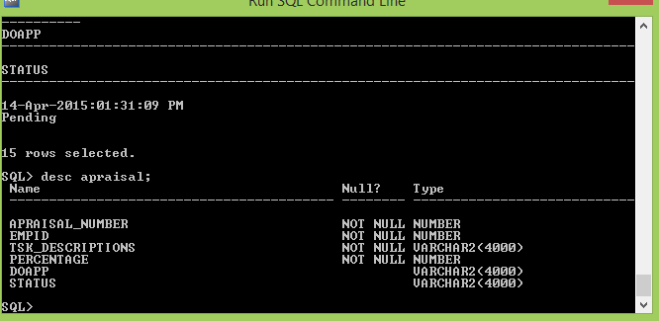

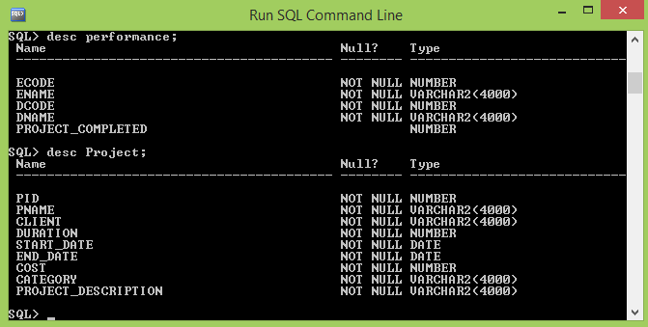

INTRODUCTION TO JAVA

CREATION OF JAVA

Java was conceived by James Gosling, Patrick Naughton, Chris Warth, Ed Frank and Mike Sheridan at SUN Microsystems Incorporation in the year 1991.It took 18 months to develop the 1st working version. This language was initially called “OAK”, but was renamed “JAVA” in 1995, many more contributed to the design and evolution of the language.

JAVA OVERVIEW

Java is a powerful but lean object-oriented programming language. It has generated a lot of excitement because it makes it possible to program for Internet by creating Applets. Programs that can be embedded in web page. The context of an applet can be an animation with sound, an interactive game or a ticker tape. With constantly updated stock prices. Applets can be just little decorations to liven up web page, or they can be serious applications like Word processor or Spreadsheet.

But Java is more than a programming language for writing Applets. It is being used more and more for writing standalone applications as well. It is becoming so popular that many people believe it will become standard language for both general purpose and Internet programming.

There are many buzzwords associated with Java, but because of its spectacular growth in popularity, a new buzzword has appeared ubiquitous. Indeed, all indications are that it will soon be everywhere.

Java builds on the strength of C++. It has taken the best features of C++ and discarded the more problematic and error prone parts. To this lean core, it has added garbage collection (automatic memory management), multithreading (the capacity for one program to do more than one thing at a time), security capabilities. This result is that Java is simple, elegant, and powerful and easy-to-use.

Java is actually a platform consisting of 3 components:
- Java Programming Language.
- Java Library of Classes and Interfaces.
- Java Virtual Machine

The following sections will say more about these components.

JAVA IS PORTABLE:

One of the biggest advantages Java offers is that it is portable. An application written in Java will run on all the major platforms. Any computer with a Java-based browser can run the applications or Applets written in the Java-Programming-Language. A programmer no longer has to write one program to run on a Macintosh, another program to run on a Windows-machine still another to run on a UNIX-machine and so on. In other words, with Java developers write their programs only once.

The Virtual Machine is what gives Java is cross platform capabilities. Rather being compiled into machine language, which is different for each OS’s and computer architecture, Java code is compiled into Byte codes.

With other languages, the program code is compiled into a language that the computer can understand. The problem is that other computers with different machine instruction set cannot understand that language. Java code on the other hand is compiled into Byte-Code rather than a machine language. These byte codes go to the JVM, which executes them directly or translates them into the language that is understood by the machine running it.

In summary, these means that with the JDBC API extending Java, a programmer writing Java code can access all the major RDBMS on any platform that supports the JVM.

JAVA IS OBJECT-ORIENTED:

The Java programming language is OBJECT-ORIENTED, which makes program design focus on what you are dealing with, rather than on how your are going to do something. This makes it more useful for programming in sophisticated projects, because one can break the things into understandable components. A big benefit is that these components can then be reused.
Object-Oriented Languages use the paradigm of classes. In simplest term, a class includes both the data and the functions to operate on data. You can create an instance of a class, also called an object, which will have all the data members and functionality of its class. Because of this, you can think of a class as being like template, with each object being a specific instance of a particular type of class.
The class paradigm allows one to encapsulate data so that specific data values are those using the data cannot see the function implementation. Encapsulation makes it possible to make the changes in code without breaking other programs that use that code.
If for example, the implementation of a function is changed, the change is invisible to any programmer who invokes that function, and does not affect his/her program, except hopefully to improve it.
Java includes inheritance, or the ability to derive new classes from existing classes. The derived class, is also called as Sub-Class, inherits all the data in the functions of the existing class.

JAVA DEVOLPMENT EVNIRONMENT

To code, edit, debug and test the java programs, one needs to have a java development environment. At the minimum this will consists of a java compiler interpreter and applet viewer where applets can be tested.
Sun’s java development kit (JDK) latest version is 2.2 can be freely downloaded from the Internet.
Java compiler is available on DOS, Win95, WIN’NT, Solaris and MAC etc.

Introduction to JavaScript

JavaScript:

JavaScript is a new scripting language for WebPages scripts written with java script can be embedded into your HTML pages. With java script you have very many possibilities for enhancing your HTML page with interesting elements. For example you are able to respond to user-initiated events quite easily. Some effects that are now possible with java script were some time ago only possible with CGI. So you can create really sophisticated pages with the helps of java script on the Internet.

Difference between java and Java Script

Although the names are almost the same Java is not the same as Java Script. These are two different techniques for Internet programming. Java is programming language. JavaScript is a scripting language as the name implies. The difference is that we can create real programs with java. But about real programming. So Java Script is meant to be easy to understand and easy to use. JavaScript authors should not have to care too much about programming. We could say that Java Script is rather an extension to HTML than a separate computer language. Of course this is not the official definition but it makes it easier to understand the difference between java and java script.

How can Java Script scripts run?

The first browser to support java script was the Netscape Navigator 2.0 of course the higher versions do have java script as well. You might know that java does not run on all Netscape Navigators 2.0 (or higher versions) versions. But this is not true for java script -although there are some problems with the different versions.
The Mac version for example seems to have many bugs. In the near future there are going to be some other browsers, which support java script. The Microsoft Internet explorer 3.0 is going to support java script. JavaScript enabled browsers are going to spread soon - it is worth learning this new technique now. You might realize that is really easy to write Java Script scripts. We have to know is some basic techniques and some work-around for problems you might encounter. Of course we need a basic. Understanding HTML before reading this tutorial you can find many really good online resources about HTML. Best you make an online search about ‘html’ at yahoo if you want to get informed about HTML. Now I want to show some small script s so you can learn how they are implemented into HTML-documents and to show which possibilities you have with the new scripting language. The following is a very small script, which will only print a text into an HTML document.

<html>
<head>
My first JavaScript
</head>
<body><br>
This is a normal HTML document
<br>
<script language=”JavaScript”>
Document.write (“this is a java script”)
</script><b r>
Backing HTML again
</body>
</html>

If you are using a java script enabled-browser at the moment then you will have the possibility to see this script working. If your browser doesn’t support Java Script then this output might be some kind of strange…

This is a normal HTML document
This is java script!
Back in HTML again.

Functions

Functions are bet declared between the <Head> tag of HTML page. Functions are called by user-initiated events. Seems reasonable to keep the functions between the <Head> tags. They are loaded first before a user can do anything that might call a function. Scripts can be placed between inside comment fields to ensure that older browser do not display the script itself.

<html>
<head>
<script language=”JavaScript”>
function pushbutton (){
alert (“Hello!”);
}
</script>
</head>
<body>
<form>
<input type=”button” name=”Button1” value=”push me” onclick=”pushbutton ()”>
</form>
</body>
</html>

If we want to test this one immediately and you are using a Java Script enabled browser then please go ahead and push the button.
This script will create a button and when you press it a window will pop up saying “hello!”. In fact we have a lot of possibilities just by adding functions to our scripts.
The common browsers transmit the form information by either method: here’s the complete tag including the GET transmission method attribute for the previous form

Example

<Form method =GET action=http://www.mycompany.com/cgi-bin/upfdate.pl>
………
</form>

Input elements.

Use the <input> tag to define any one of a number of common form elements including text fields multiple choice lists click able images and submission buttons. There are many attributers for this tag only that types and name attributes are required for each element, each type of input element uses only a subset of the followed attributes. Additional <input> attributes may be required based upon which type of the form element you specify.

Submit button:

The submit button (<input type=submit>) does what its name implies, settings in motion the form’s submission to the server from the browser. We many have more than submit buttons will be added to the parameter list the browser sends along to the server.

Example
< Input type =”submit”>
<Input type=”submit” value=”submit” name=”name”>

Reset button:

The reset button if firm <input> button is nearly self- explanatory; it lets the user reset erase or set to some default value all elements in the form. By default the browser displays a reset button worth the label “reset”. We can change that by specifying a value attribute with tour own button label.

INTRODUCTION TO JDBC

JDBC (Java Database connectivity) is a front-end tool for connecting to a server to ODBC in that respect, however JDBC can connect only java client and it uses ODBC for the connectivity. JDBC is essentially a low-level API since any data manipulation, storage and retrieval has to be done by the program itself. Some tools, which provide a higher-level abstraction, are expected shortly.
The next question that needs to be answered is why we need JDBC, once we have ODBC on hand. We can use the same ODBC to connect the entire database and ODBC is a proven technology.
Problem for doing this is ODBC gives a ‘c’ language API, which uses pointers extensively. Since java does not have any pointes and is object-oriented sun Microsystems, inventor of java developed to suit its needs.

Requirements to use JDBC:

To use JDBC you need a basic knowledge of databases and SQL.A part from this you need the jdk1.1 (Java Development Kit1.1 available javasoft’s website) or a version of Java since jdk1.1 and above come bundled with JDBC software.
After that you need to have a back-end database engine for which a JDBC driver is available. When JDBC drivers are not available JDBC-ODBC bridge drivers are used to access the database through ODBC.Back-end is not needed when JDBC driver is capable of storing and retrieving the data itself, or if JDBC-ODBC Bridge and the ODBC driver can be used to store and retrieve the information.

DATABASE MODELS

JDBC and accessing the database through applets and JDBC.API via an intermediate server resulted server resulted in a new type of database model which
is different from the client-server model. Based on number of intermediate server through the request should go it is named as single tire, two tire and multi tire architecture

Single Tier

In a single tier the server and client are the same in the sense that a client program that needs information (client) and the source of this type of architecture is also possible in java, in case flat files are used to store the data. However this is useful only in case of small applications. The advantage with this is the simplicity and portability of the application developed.

Server and client

Database

Two Tier (client-server)

In two architecture the database resides in one machine the network. In this type of architecture a database management takes control of the database and provides access to clients in a network. This software bundle is also called as the server. Software in different machines, requesting for information are called as the clients.

Server

Client

Database

Client

Three Tier and N-Tier

In the three-tier architecture, any number servers can access the database that resides on server. Which in turn serve clients in a network. For example, you want to access the database using java applets, the applet running in some other machine, can send request only to the server from which it is down loaded. For this reason we will need to have a intermediate server which will accept the requests from applets and them to the actual database server. This intermediate server acts as a two-way communication channel also. This is the information or data from the database is passed on to the applet that is requesting it. This can be extended to make n tiers of servers, each server carrying to specific type of request from clients, however in practice only 3 tiers architecture is popular.

JDBC Driver Types:

The JDBC drivers that we are aware of at this time fit into one of four categories

1. JDBC-ODBC BRIDGE PLUS ODBC DRIVER

The java soft bridge product provides JDBC access via ODBC drivers. Note that ODBC binary code end in many cases database client code must be loaded on each client machine that uses this driver. As a result, this kind of driver is most appropriate on a corporate network where client installations are not major problem, or for application server code written in java in a 3-tier architecture.

2. NATIVE API PARTLY-JAVA DRIVER

This kind of driver converts JDBC calls into calls on the client API for oracle Sybase, Informix, DB2, or other DBMS. Note that, like the bridge driver, this style of driver requires that some binary code be loaded on each client machine.

- JDBC-NET ALL-JAVA DRIVER

This driver translates JDBC calls into a DBMS independent net protocol, which is then translated, to a DBMS protocol by a server. This net server middle-ware is able to connect its all java clients to many different databases. The Specific protocol used depends on the vendor. In general, this most flexible JDBC alternative. It is likely that all vendors of this solution will provide products suitable for intranet use. In order for these products to also support Internet access, they must handle the additional requirements for security, access through firewalls, etc that the web imposes. Several vendors are adding JDBC drivers to their existing database middleware products.

- NATIVE PROTOCOL ALL-JAVA DRIVER

This kind of driver converts JDBC calls into the network protocol used by DBMS directory. This allows a direct call from the client machine to the DBMS server that is practical solution for intranet access. Since many of these protocols are proprietary, the database vendors themselves will be the primary source. Several database vendors have these in progress. Eventually, we expect that driver categories 3 and 4 will be the preferred way to access databases from JDBC. Driver categories one and two are interim solutions where direct all java drivers are not yet available. Category 4 is in some sense the ideal; however, there are many cases where category 3 may be preferable: eg: -where a thin DBMS-independent client is desired, or if a DBMS –independent protocol is standardized and implemented directly by many DBMS vendors.

Screen Shots (Forms & Reports)



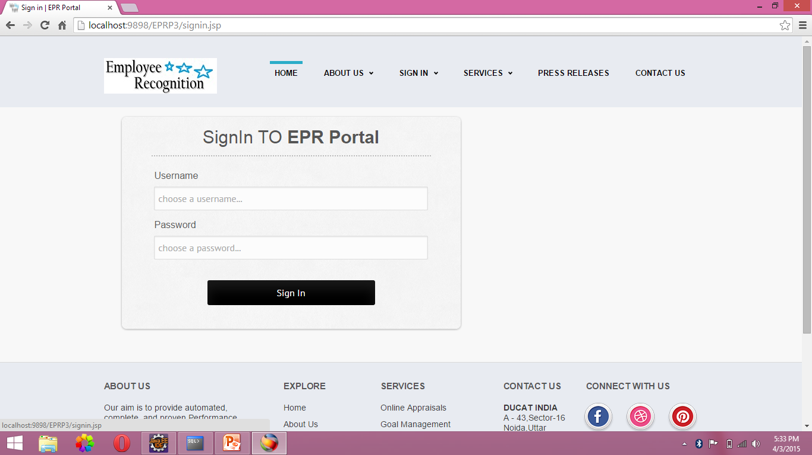

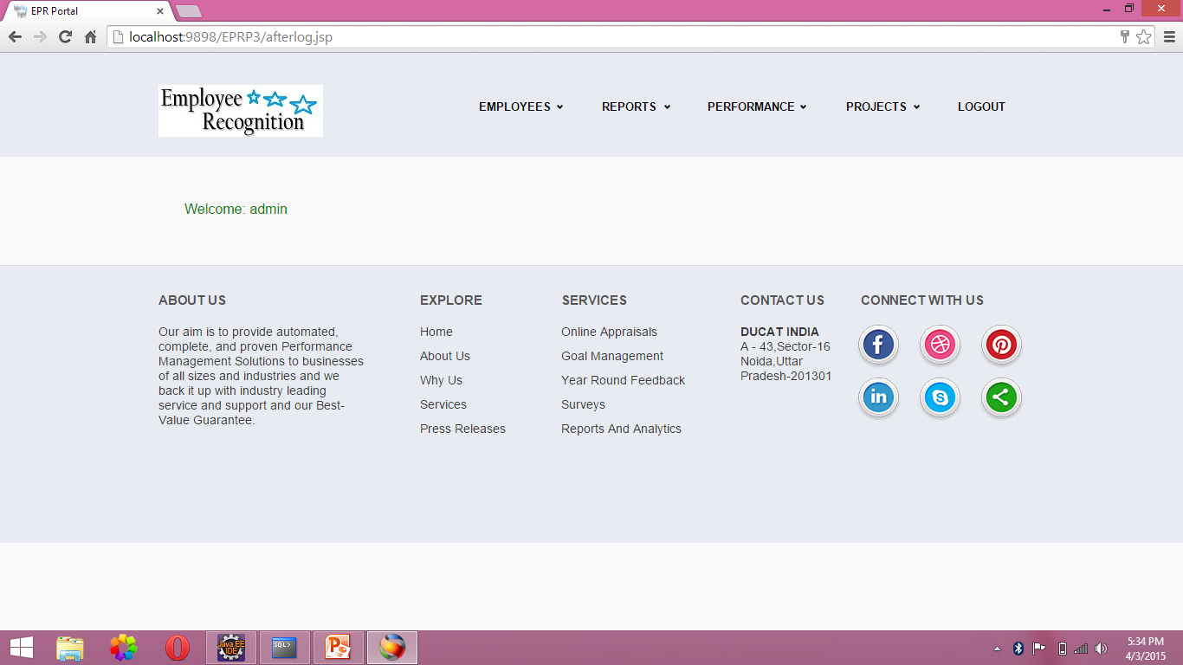

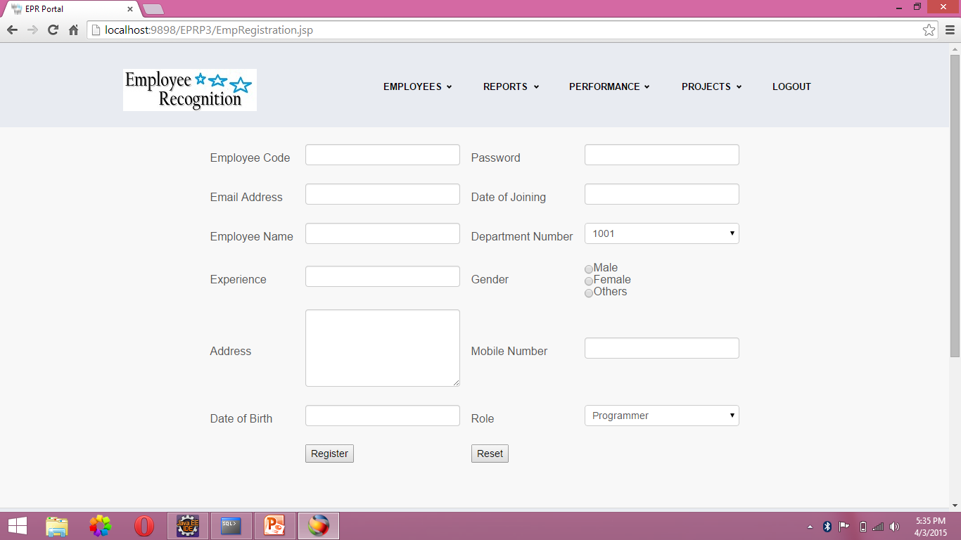

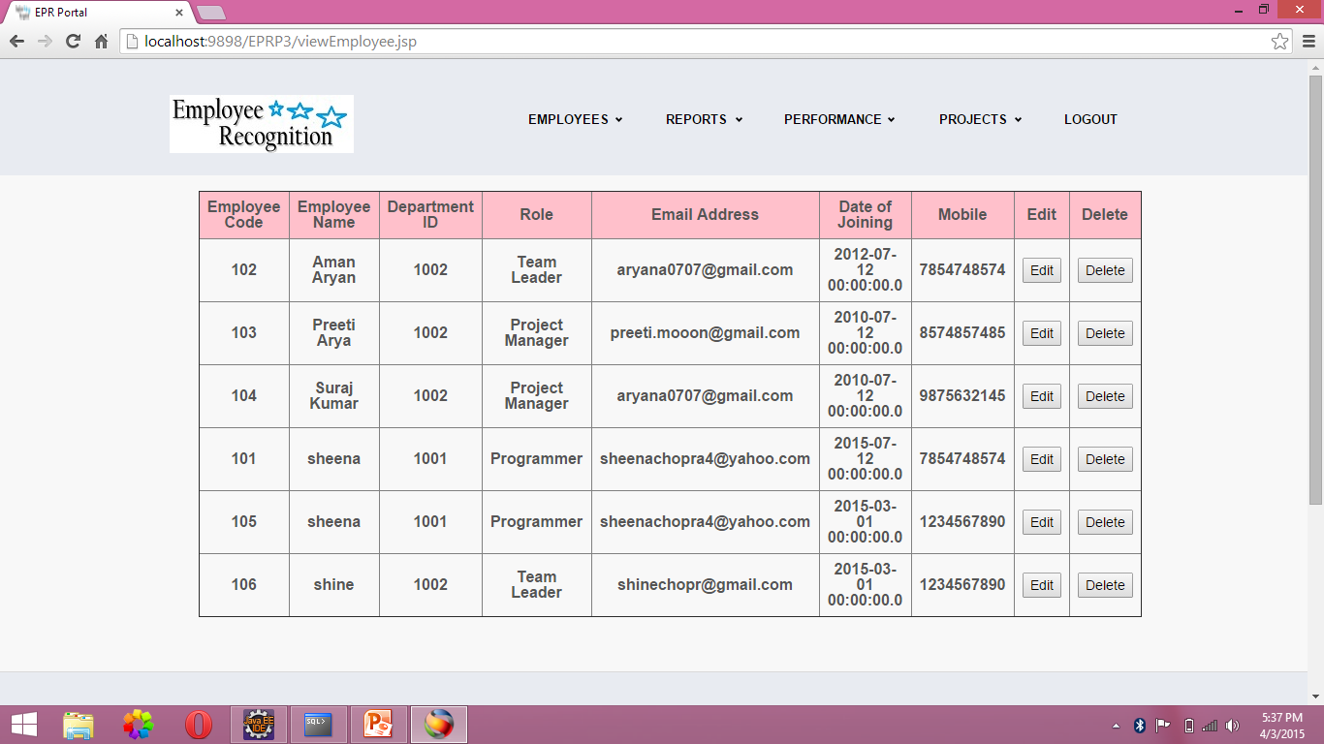

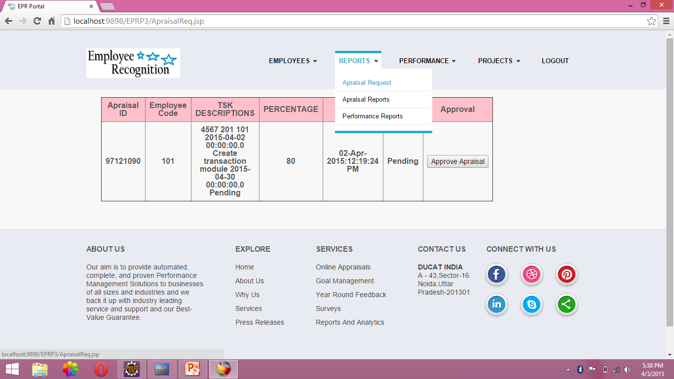

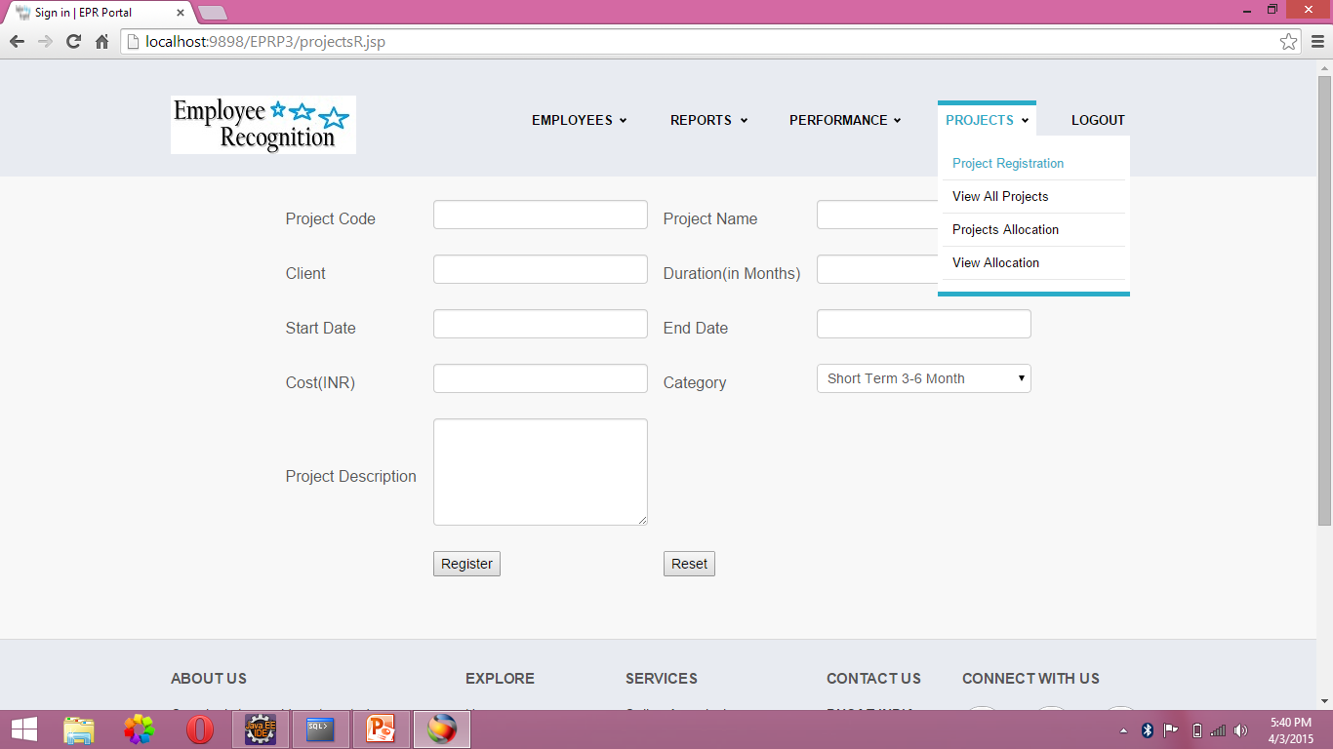

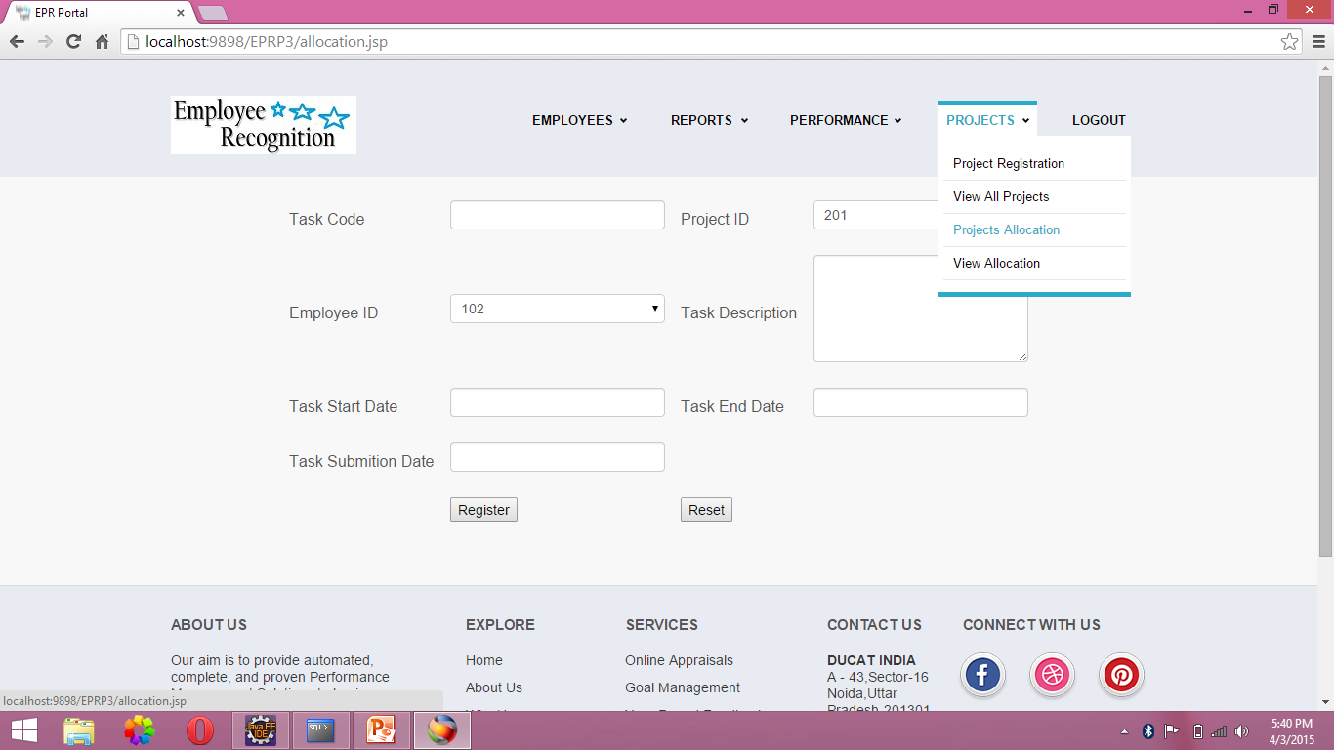

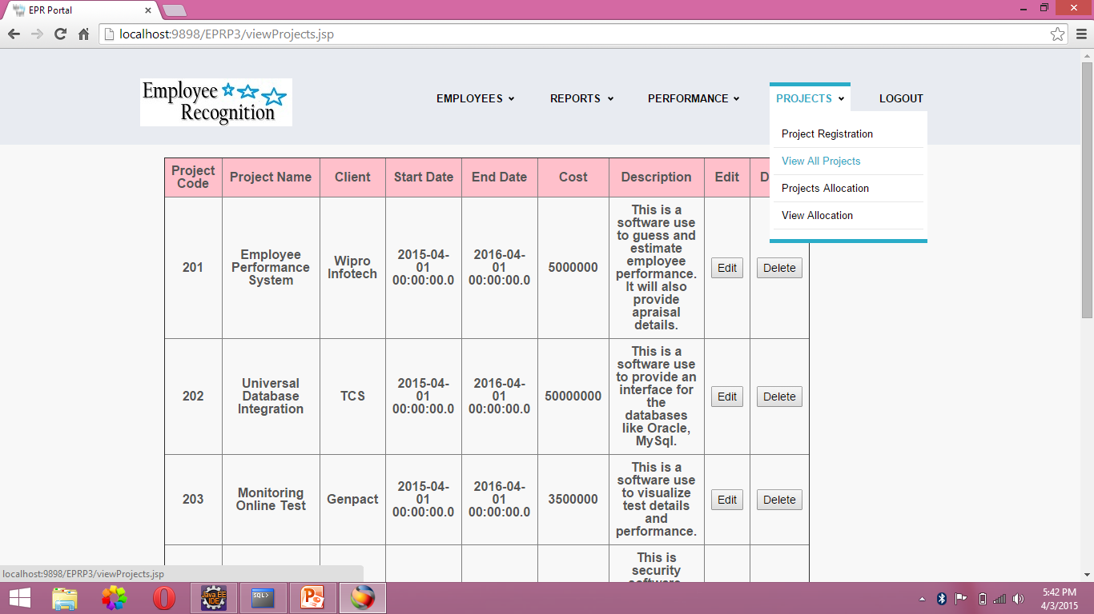

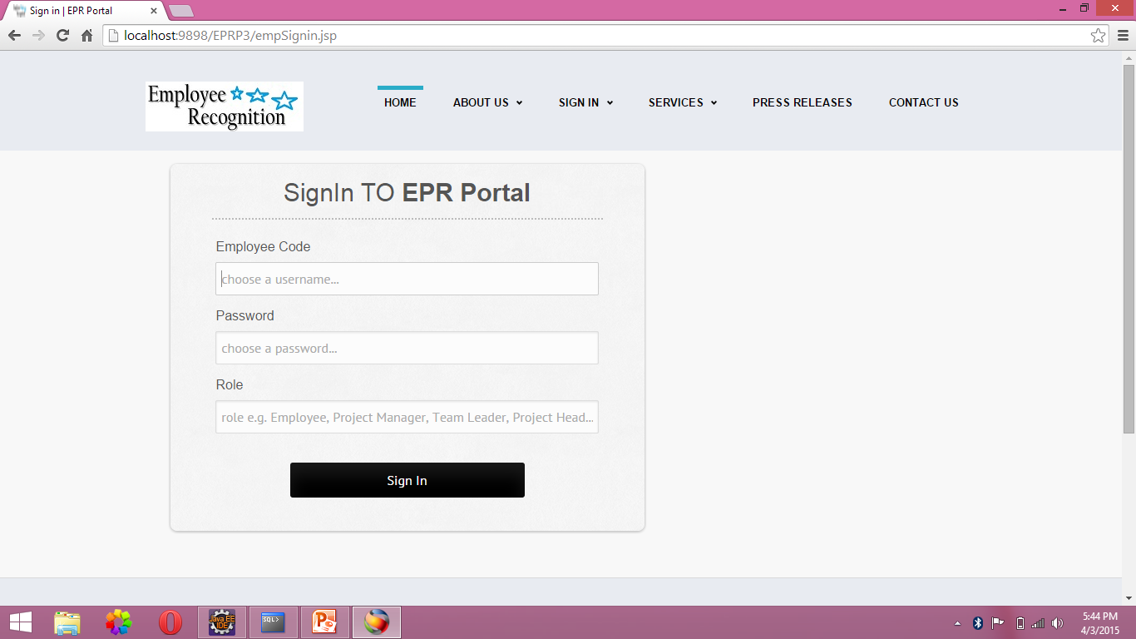

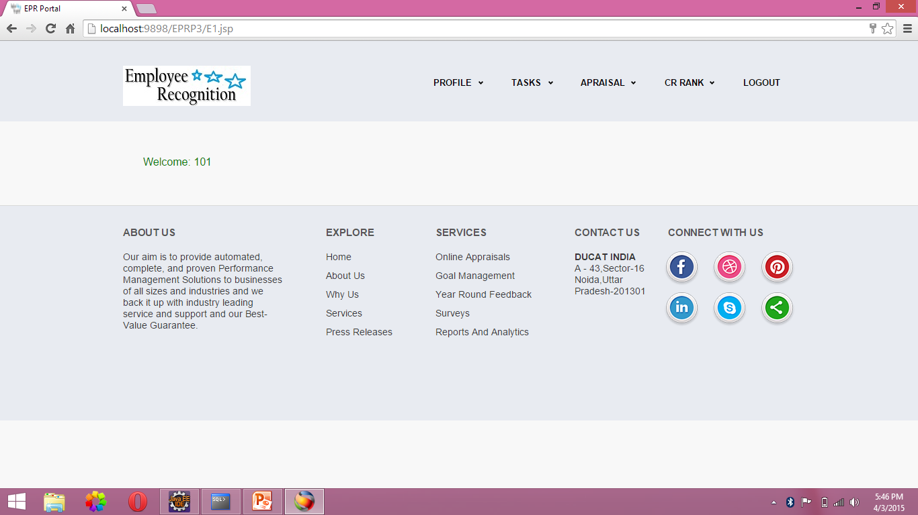

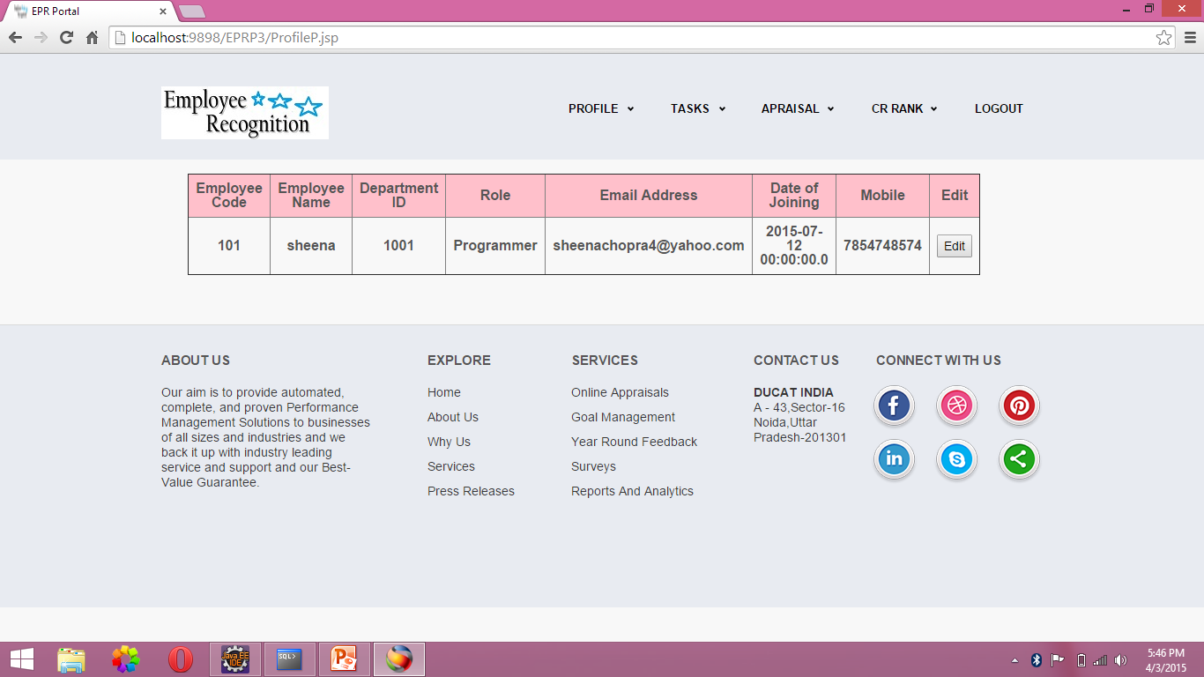

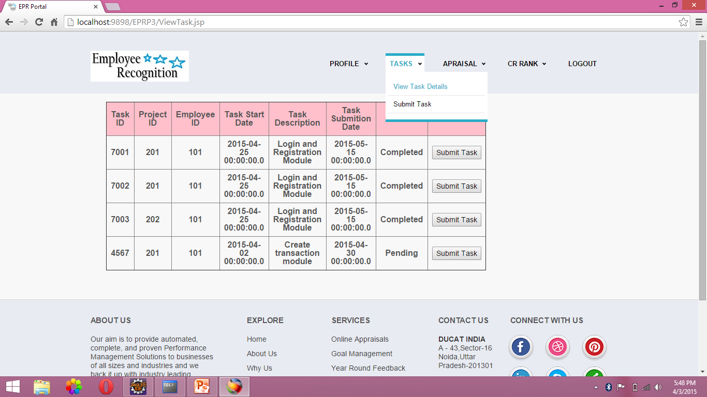

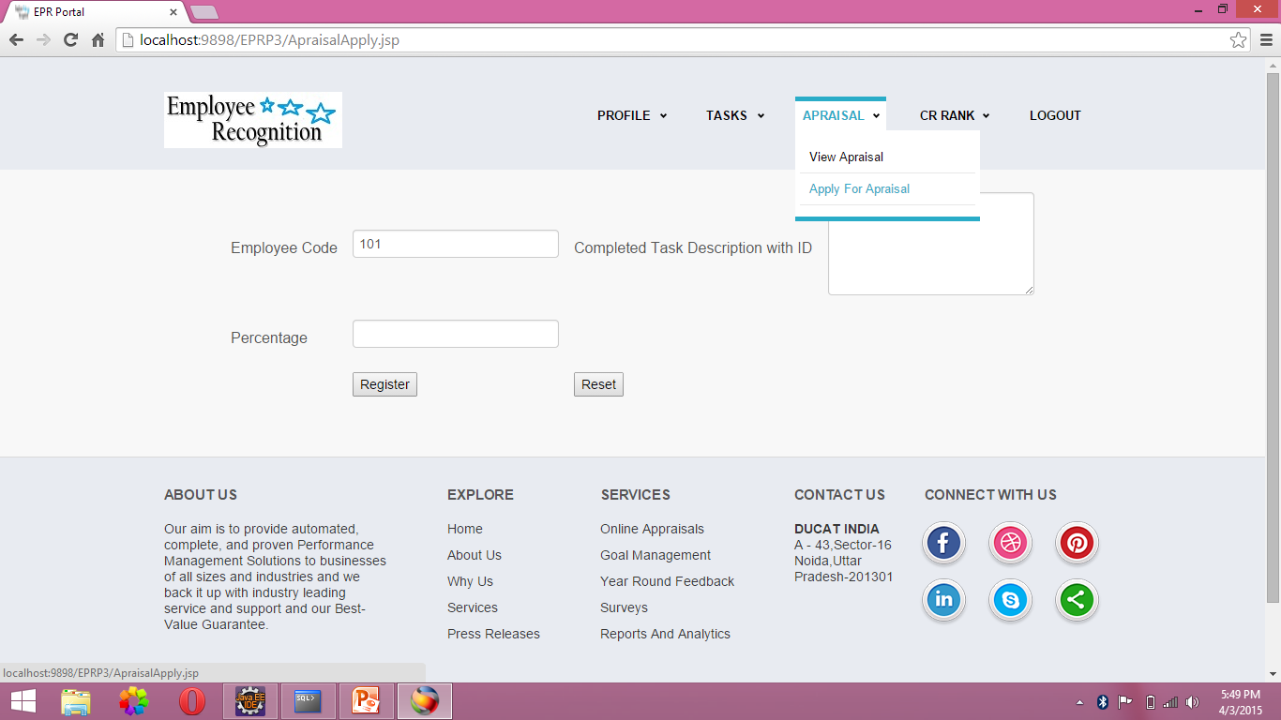

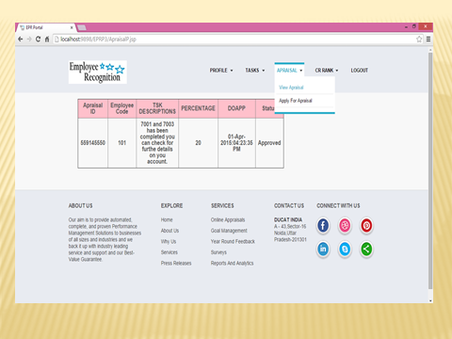

Software Testing

Software Testing is a critical element of software quality assurance and represents the ultimate review of specification, design and coding, Testing presents an interesting anomaly for the software engineer.

Testing Objectives include:

- Testing is a process of executing a program with the intent of finding an error
- A good test case is one that has a probability of finding an as yet undiscovered error
- A successful test is one that uncovers an undiscovered error

Testing Principles:

- All tests should be traceable to end user requirements
- Tests should be planned long before testing begins
- Testing should begin on a small scale and progress towards testing in large
- Exhaustive testing is not possible
- To be most effective testing should be conducted by a independent third party

Testing Strategies

A Strategy for software testing integrates software test cases into a series of well planned steps that result in the successful construction of software. Software testing is a broader topic for what is referred to as Verification and Validation. Verification refers to the set of activities that ensure that the software correctly implements a specific function Validation refers he set of activities that ensure that the software that has been built is traceable to customer’s requirements

Unit Testing:

Unit testing focuses verification effort on the smallest unit of software design that is the module. Using procedural design description as a guide, important control paths are tested to uncover errors within the boundaries of the module. The unit test is normally white box testing oriented and the step can be conducted in parallel for multiple modules.

Integration Testing:

Integration testing is a systematic technique for constructing the program structure while conducting test to uncover errors associated with the interfacing. The objective is to take unit tested methods and build a program structure that has been dictated by design.

Top-down Integration:

Top down integrations an incremental approach to construction of program structure. Modules are integrated by moving downward through the control hierarchy, beginning with the main control program. Modules subordinate to the main program are incorporated in the structure either in the breath-first or depth-first manner.

Bottom-up Integration:

This method as the name suggests, begins construction and testing with atomic modules i.e., modules at the lowest leveling the program structure.

System Test Cases & System Test Report

The system test cases mentioned below are expected to work and give the expected behavior if the explorer is configured to run jar files as mentioned in the project folder. The necessary library files and standard jar files are in the appropriate project directories and the path and class path environment variables are appropriately set.

Test  C.No. | Input | Expected Behaviour | Observed  behaviour | Status  P = Passed  F = Failed
1 | Login as admin with correct login details | Admin Home page for admin should be displayed | -do- | P
2 | Login as admin with wrong login details | Error message should be displayed | -do- | P
3 | Add a New Entry for an employee | It should add a new record in the database with new employee details | -do- | P
4 | Delete Entry | It should delete an existing employee from the database | -do- | P
5 | Add login details to an employee | Login details of this employee should be stored inside the DB | -do- | P
6 | Add an entry to create project details | New Project details should be added. | -do- | P
7 | Login as Appraisee | Appraisee home page should be displayed | -do- | P
8 | Set the appraiser for this appraisee | It should be added in the DB | -do- | P
9 | Submit an employee appraisal | Appraisal should be send to his appraiser | -do- | P
10 | View the list of appraisals | Apprise appraisals  Should be displayed | -do- | P
11 | Login as appraiser | Appraiser home page should be displayed | -do- | P
12 | View appraisal list | List of appraisals should be displayed. | -do- | P
13 | Evaluate the appraisals | Appraisals should be evaluated | -do- | P
14 | Login as appraisee and send a reviewer request | It should send a review request | -do- | P

Validation Testing:

At the end of integration testing software ids completely assembled as a package. Validation testing is the next stage which can be defined as successful when the software functions in the manner reasonably expected by the customer. Reasonable expectations are those defined in the software requirements specifications. Information contained in those sections form a basis for validation testing approach.

System Testing:
System testing is actually a series of different tests whose primary purpose is to fully exercise the computer-based system. Although each test has a different purpose, all work to verify that all system elements have been properly integrated to perform allocated functions.
Recovery Testing:

It is a system test that forces the system to fail in a variety of ways and verities that the recovery is properly performed.
Security Testing:

Attempts to verify the protection mechanisms built into the system.
Performance Testing:

This method is designed to test runtime performance of software within the context of an integrated system..

Limitations and Enhancements

1). Limitations:

- Once the user (employee) submits a document then he is not going to have the immediate response from the expert. We call this is as offline response. Some times it is better to provide online response in that situation user can get the status of his request immediately and gets wide thinking.
- It is only the intranet application. Because of this if any employee is working from client place then he can’t enter into this application from online since it’s access is restricted with in the company..

2) Enhancements:

- Extendibility ----provides high level extendibility. It means it provides all the basic features and allows us to extend their features very easily with out disturbing the existing code.
- We can make this Internet application if we desire.
- We can make this application is suitable to work on any application just by changing the deployment files.
- By providing some more features like providing accessibility to internet users to involve in this process.

Conclusion

The new system, Employee Performance and Recognition Portal has been implemented to cater the needs of company employees and administrative people of the company in submitting appraisals, evaluating the appraisals, calculating the average ratings of the employees and finally generating the consolidated ranks effectively with role based access. The present system has been integrated with the already existing. The database was put into the My SQL server. This was connected by JDBC. The database is accessible through Intranet on any location. This system has been found to meet the requirements of the users and departments and also very satisfactory.

The database system must provide for the safety of the information stored, despite system crashes or attempts at unauthorized access. If data are to be shared among several users, the system must avoid possible anomalous results.

Bibliography

Reference text books

- Core java volume-II Advanced features 7th edition by Cay S.Horstmann and Gary Cornell (Pearson education).
- Java Servlet Programming by O’relly publishers
- Java Complete Reference 5th edition by Herbert Schildt (Tata McGraw Hill).
- Algorithm and applications in java 3rd edition by Satraj Sahni (Tata McGraw Hill).
- Classical Data Structures by Samantha (Pearson education).
- Java Server Programming 2.0 with complete J2EE concepts included (apress).
- Software Engineering practice and principles 6th edition by Roger Pressmen (Tata McGraw Hill).
- Java How to program 5th edition Deitel and Deitel (Prentice Hall of India).
- Internet & World Wide Web How to program 3rd edition by Deitel & Deitel and Goldberg (Pearson education).
- Web enabled commercial application development using Java 2.0 by Ivan Bayross (Prentice Hall of India).
- Data base System Concepts 4th edition by Silbershatz, Korth, and Sudharshan (Tata McGraw Hill).
- Fundamentals of Data base systems 4th edition by Ramez Elmasri and Shamkant B.Navathe (Pearson education).

Websites
- www.javaworld.com
- www.apaache.org
- www.java.sun.com
- www.w3schools.com
- www.itpapers.com

